

|  |
| --- |
| [Version 1.1]  **Last saved by:** Ben McGregor  **Last saved on:** 31/03/2015 |

|  |
| --- |
| Iteration 8 Plan |
| 01/02/2015 |
| **Charlotte Hutchinson**  CO600: JustHealth Supervisor: Yang He |

Contents

1.0 Aims: 2

2.0 Requirements: 2

2.1 Functional requirements: 2

2.2 Non-functional requirements: 2

2.3 Domain Requirements: 2

3.0 Design 3

3.1 Web notifications 3

Medication and Appointment reminders 4

3.2 Android notifications 4

4.0 Use cases: 5

4.1 Web general notifications 5

4.2 Web Password reminder 5

4.3 Web appointment notification 6

4.4 Web Prescription notification 6

4.5 Android push notifications system 7

JustHealth Iteration 8 Plan

# Aims:

* Reminder functionality for both android and web to remind patients to take medication and when appointments are.
* A notification system on both android and web so users are able to see requests or reminders.
* A way to store the past notifications for a user to view
* Different color notifications based on how important they are
* Initial progress on the admin portal

# Requirements:

## 2.1 Functional requirements:

1. A reminder functionality to remind patients when to take medication- Web
2. A reminder functionality to remind patients when to take medication- Android
3. A reminder functionality to remind patients when appointments are- Web
4. A reminder functionality to remind patients when appointments are- android
5. Notification system- web
6. Notifications system- android

## 2.2 Non-functional requirements:

1. User Documentation
2. Security
   1. Ensuring only certain people can enter medication details
   2. A safe way for people to enter medication and unable to make human errors
   3. Secure ways of dealing with push notifications
   4. Safe connection with the android calendar
3. Robustness
   1. Error handling
   2. Security (as above)
4. Ease of Use
   1. Simple and intuitive design
   2. Clear colour scheme
   3. Clear and easy way for both patients and users to view notifications

## 2.3 Domain Requirements:

1. Security (Android)
   1. Ensuring a user understands the connection with their phone calendar
2. Push notifications in Android linking with the google cloud
3. Legal- a user a where and accepts the fact push notifications will be optional on the android application.

# Design

## 3.1 Web notifications

The user will be able to view their new notifications by clicking the icon in the header. If they use the notifications link in the navigation menu, it will take them to a page containing all their notifications. The notifications will be displayed in order (latest at the top)

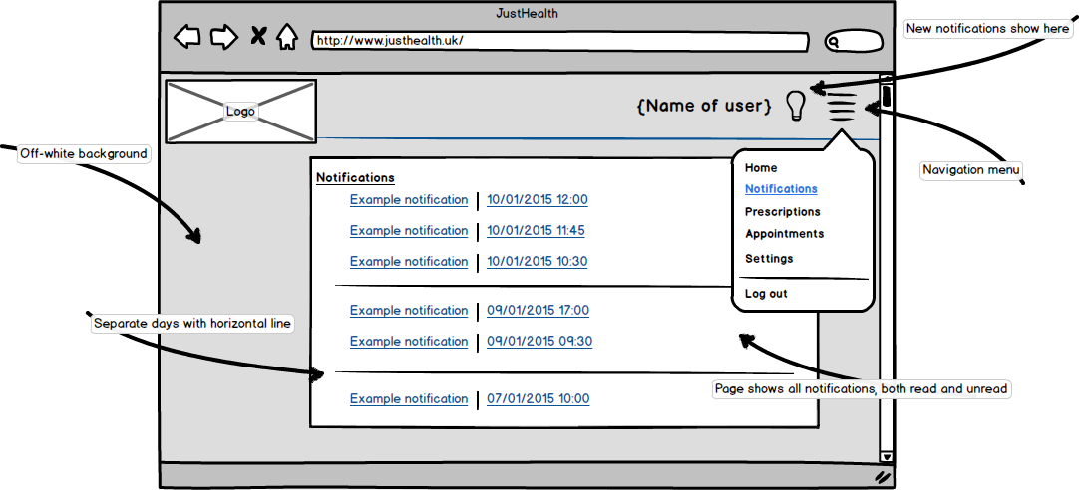

### C:\Users\benmcg92\AppData\Local\Microsoft\Windows\INetCache\Content.Word\webreminders.pngMedication and Appointment reminders

The user will be shown important notifications and reminders on their dashboard, these will be dismissible, and they can update that they have taken medication from the notification etc.

## 3.2 Android notifications

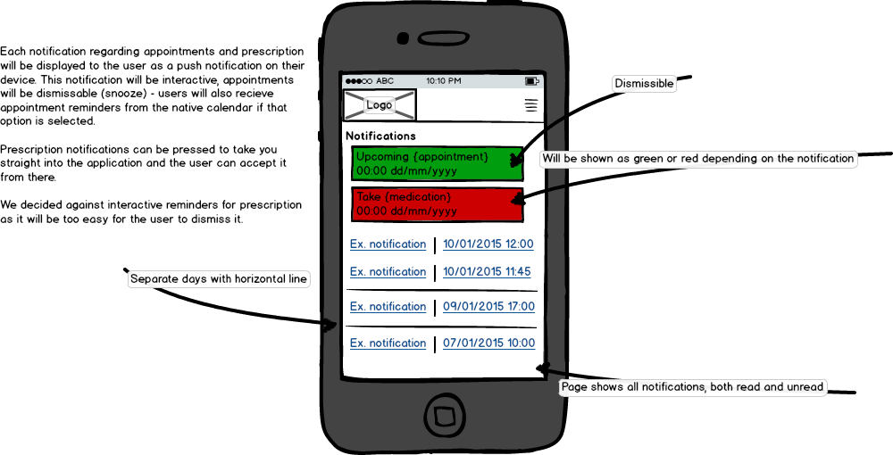This page is at its initial stages and will need refining, the user experience will need testing properly. All push notifications will use the default android theme of the device, but will show the JustHealth log

# Use cases:

## 4.1 Web general notifications

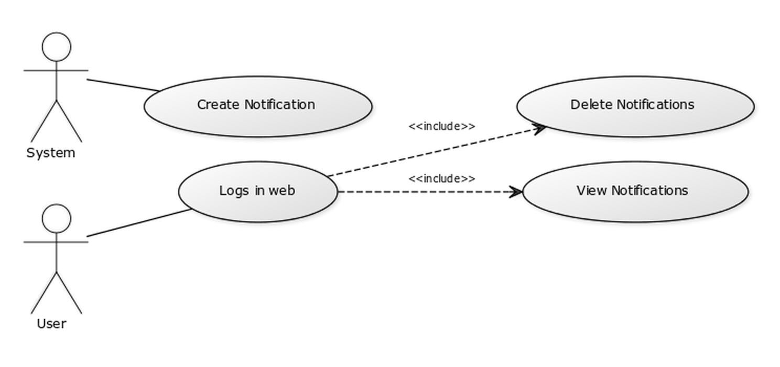

## 4.2 Web Password reminder

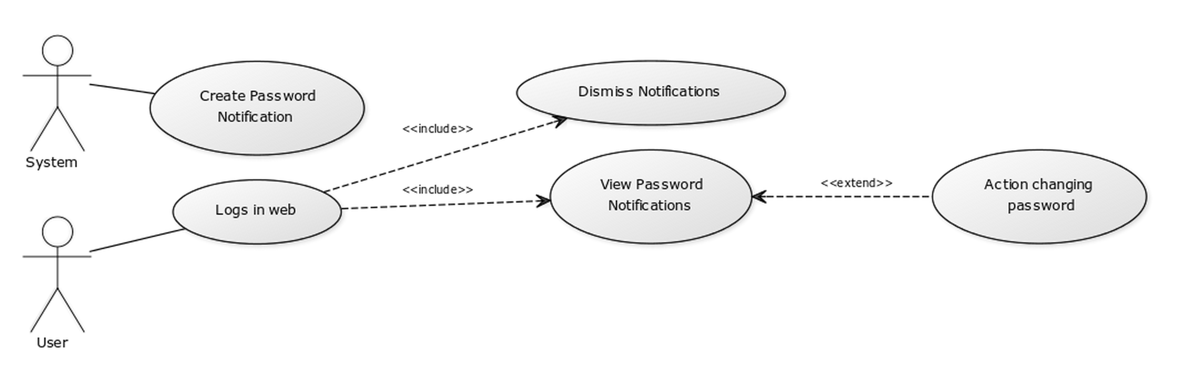

## 4.3 Web appointment notification

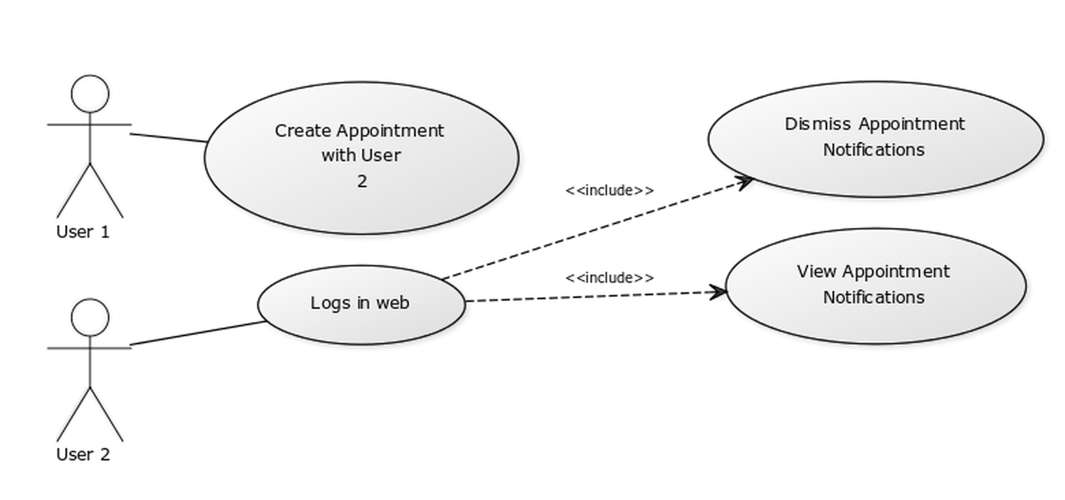

## 4.4 Web Prescription notification

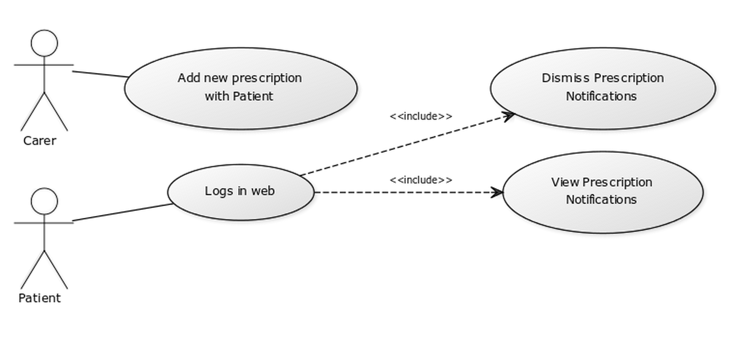

## 4.5 Android push notifications system

